Get Your Affairs in Order: 4 things your
family will thank you for!
SEMINAR
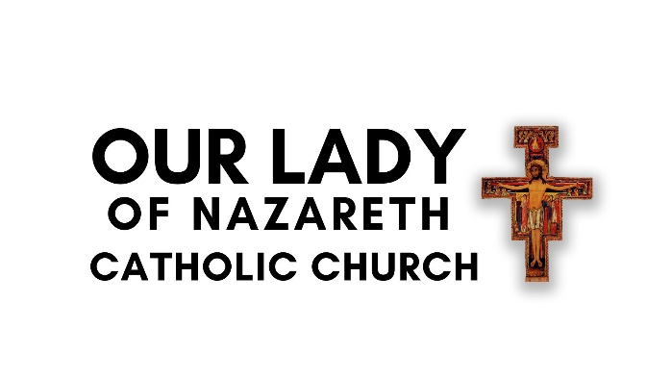
Did you know your Will may be out of date? Are your Advanced Medical Directives aligned with Catholic Church Teachings?
Do you have a POD in place?
This is a free, information-only seminar. Refreshments served.
Select from one of the times below:
Tuesday, March 11th at 6:00PM
Wednesday, March 12th at 9:00AM
Reserve your seat! RSVP to the parish office at (540) 774-0066.

TOPICS INCLUDE:

- Catholic Advanced Medical Directives
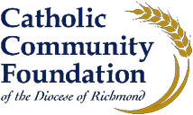
- Catholic Funeral Planning
- Wills vs. Trusts
- Legacy Planning
- Beneficiaries and Designations
- Guardianship

